# Hardware and Installation Manual

## In this manual

You will find instructions for your OpenBCI headset: how to use the headset, connect it to your system, adjust the electrodes location, and an overview on the hardware itself.

## Need hardware support or repairs?

The manual was written by Or Rabani. If you need any help, please contact her through your TA.

## Table of Content

Hardware and Installation Manual

In this manual

Need hardware support or repairs?

Table of Content

Initial set-up

How to connect to your openBCI (Cyton+Daisy)

Correct order of setup

Insert batteries to battery holder

Connect the dongle to your computer

Power up OpenBCI board

Connect to OpenBCI GUI

Set LSL broadcast

End session

OpenBCI GUI auto-recording (*.txt file)

Placing the system on a participant

Electrodes positions

10-20 positions

Electrodes positions on openBCI board & GUI

Hardware overview & specs

OpenBCI processing board and network dongle

Headset

Additional resources

# Initial set-up

The instructions are for Windows OS, please follow similar steps for Linux or Mac OS.

1. Re-configure VCP:
   1. Go to: Control Panel > Device Manager > Ports > USB Serial Port (your COM port for the dongle) > Port Settings > Advanced.
   2. Set: Latency Timer to 1ms
   3. Do this for all the USB ports you may use with the dungle in the future.
2. Make sure you are working on 64 bit operating system:
   1. Go to: Start menu> Settings > System > About
   2. The OS version is listed under Device specifications > System type.
   3. If you are using a 32 bit operating system, replace your OpenBCI GUI with the 5.0.4 version of the GUI, and notify the staff (this might cause compatibility issues within your team).

# How to connect to your openBCI (Cyton+Daisy)

## Correct order of setup

Batteries > dongle > board > GUI

## Insert batteries to battery holder

1. Be mindful not to disconnect any wires.
2. The system uses 4 X AA 1.5V batteries.  
   When batteries drain, the signal may get distorted.
3. NEW before every use, measure the voltage of the batteries.   
   Voltage should be above 1.4V.   
   If it is lower, replace the battery (you can use it for any other device - it is still strong, but not enough for our use)  
   **For the first two weeks, please label the batteries 1 to 4 and** [**keep track of their voltage here**](https://docs.google.com/spreadsheets/d/1jb-E3Xg_QDfLi29JHlU0nmmo-KHx4kqnWMD1iaIqrhI/edit?usp=sharing) **- This will help us learn & improve.**
4. Please remember to remove the batteries after every use and **store them outside of the headset’s box**. The weight of the batteries may damage the headset.

## Connect the dongle to your computer

1. Dongle should indicate status via a blue light on it  
   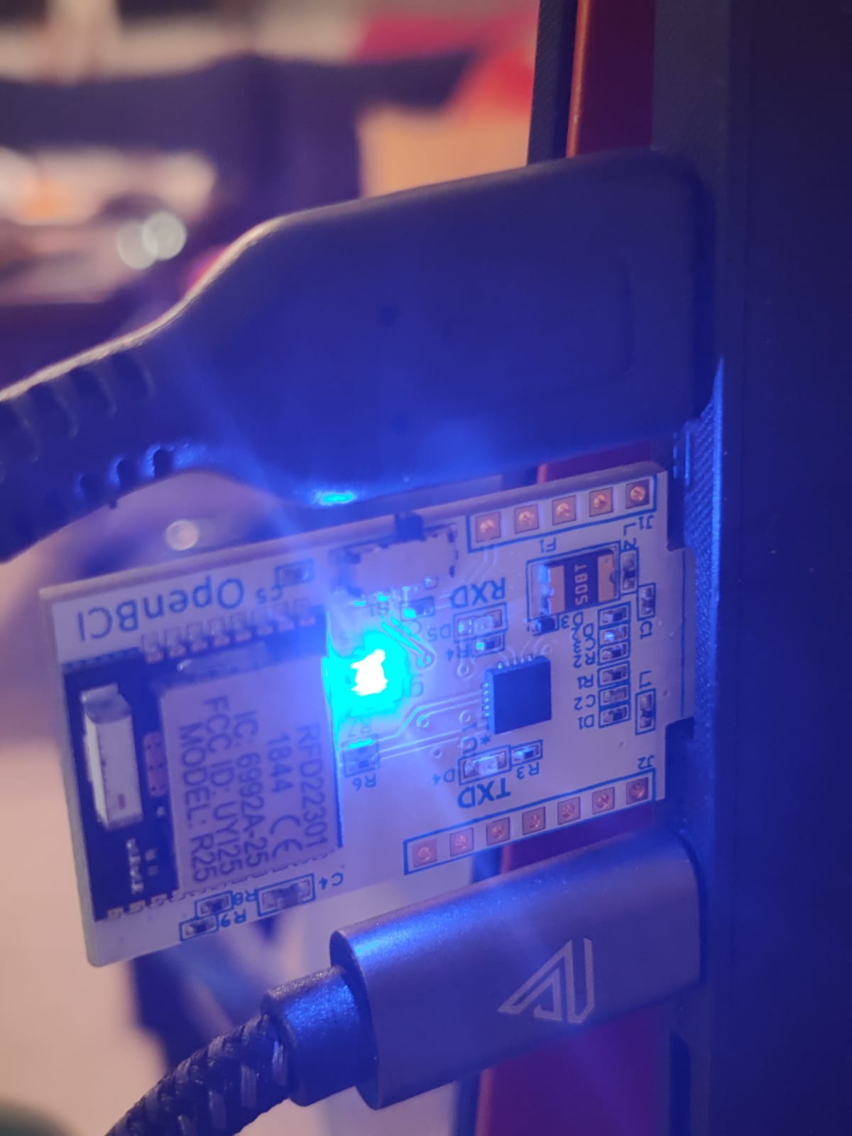
2. Troubleshooting:
   1. Make sure nothing is touching the dongle (device is conductive)
   2. Dongle should be in the correct USB orientation (gold contact stripes facing upwards)
   3. Dongle physical switch should always be set to GPIO6
   4. Change USB port
   5. If the dongle shuts down after ~10 seconds:
      1. Follow these instructions
         1. Disabling USB power saving ([from device manager](https://www.techwalla.com/articles/how-to-adjust-usb-power))
         2. Disabling USB selective suspension ([from power settings](https://www.windowscentral.com/how-prevent-windows-10-turning-usb-devices))
         3. Installing virtual com port drivers here ([download executable here](https://www.ftdichip.com/Drivers/VCP.htm))
      2. If this fix doesn't work, try [this one](https://www.howtogeek.com/296918/how-to-stop-windows-from-powering-off-your-usb-devices/).

## Power up OpenBCI board

1. Set three-way switch to PC (up position).  
   Switch is located on the right hand side of board  
   Note that OFF is the middle switch position.  
   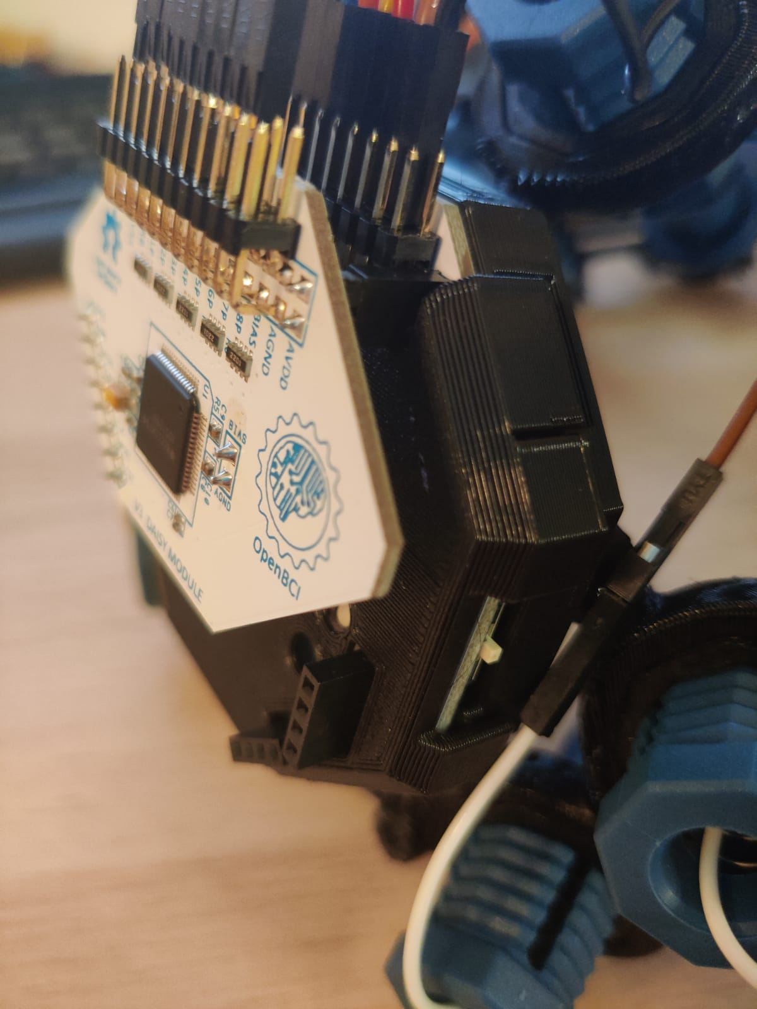
2. Board should indicate status via a blue light on it  
   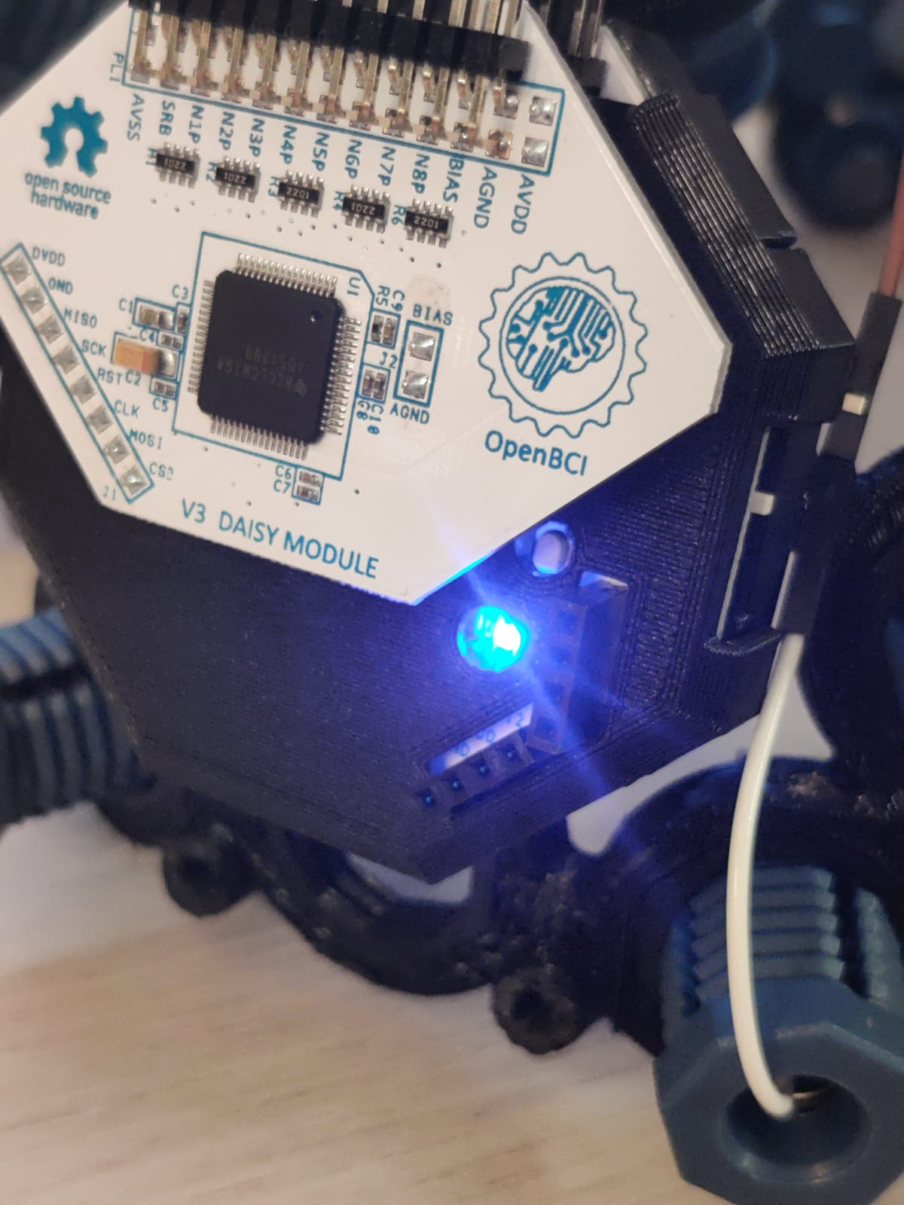
3. Troubleshooting:
   1. Make sure switch is set to PC mode
   2. Check power extension cord connector (white box connector, wire color may vary)  
      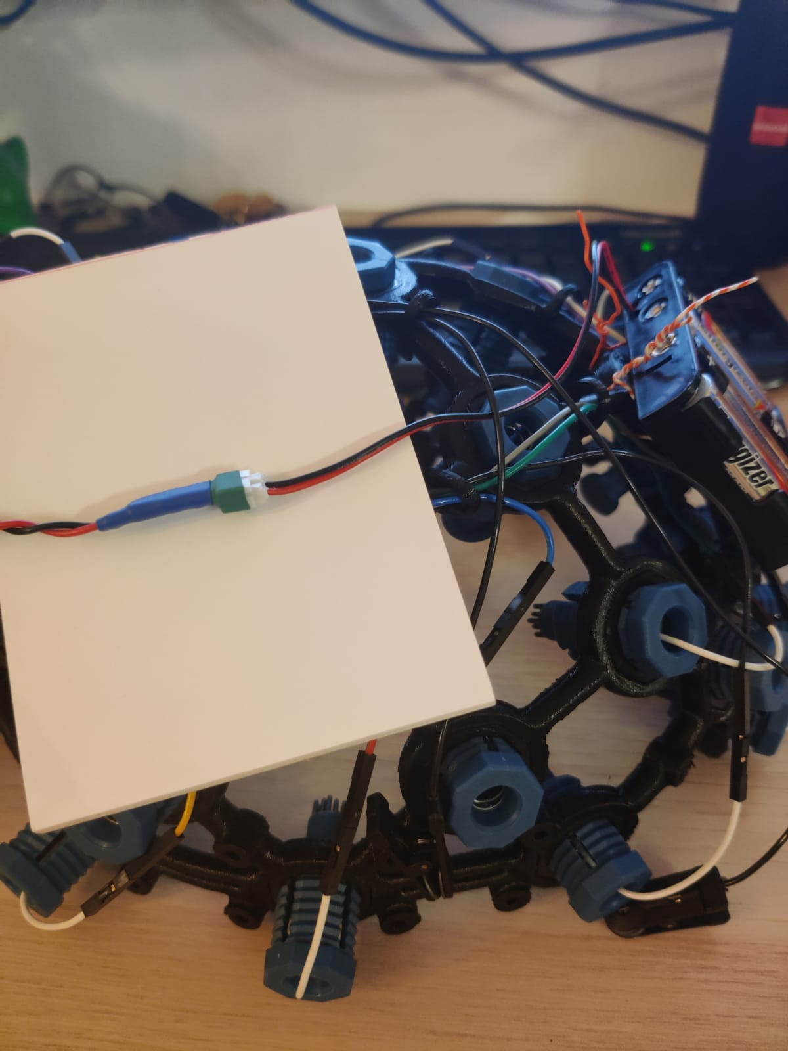
   3. Change batteries

## Connect to OpenBCI GUI

1. First time connecting this specific headset to your computer?  
   Follow these instructions ([link](https://openbci.com/forum/index.php?p=/discussion/200/latency-timer-windows-control-panel-setting)) to change the latency timer settings in your USB port.
2. open OpenBCI GUI
3. On main screen, set the following:  
   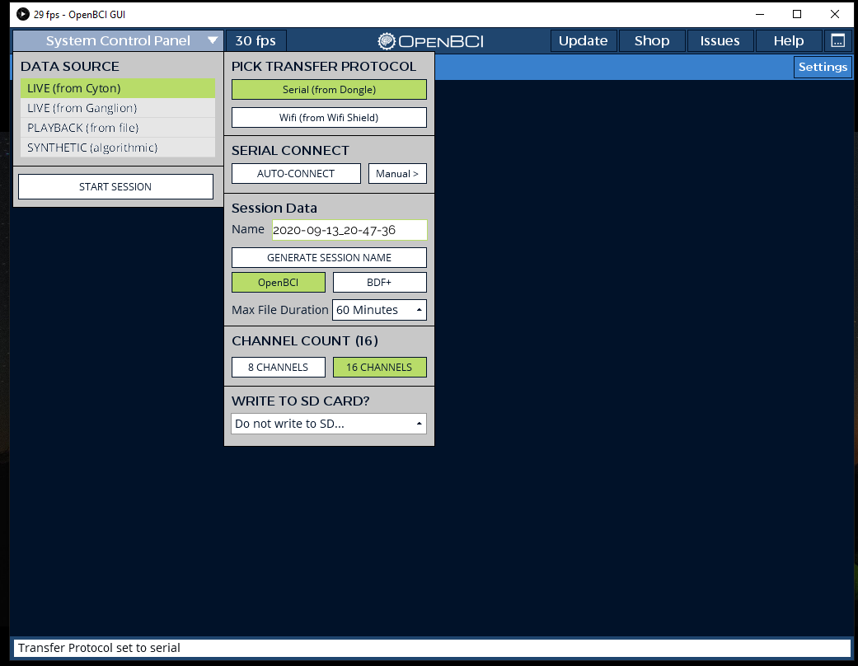
   1. **Data Source:** LIVE (from Cyton)  
      Note that the system can also:  
      (1) playback a file that has been recorded in the past;   
      (2) produce synthetic signals for testing.
   2. **Pick Transfer Protocol:** Serial (from Dongle)
   3. **Session Data:** do not change settings
   4. **Channel Count:** 16 Channels
4. Set: **Serial connect:** Auto-connect
   1. Troubleshooting:  
      If Auto connect doesn't work:
      1. **Serial connect:** Manual  
         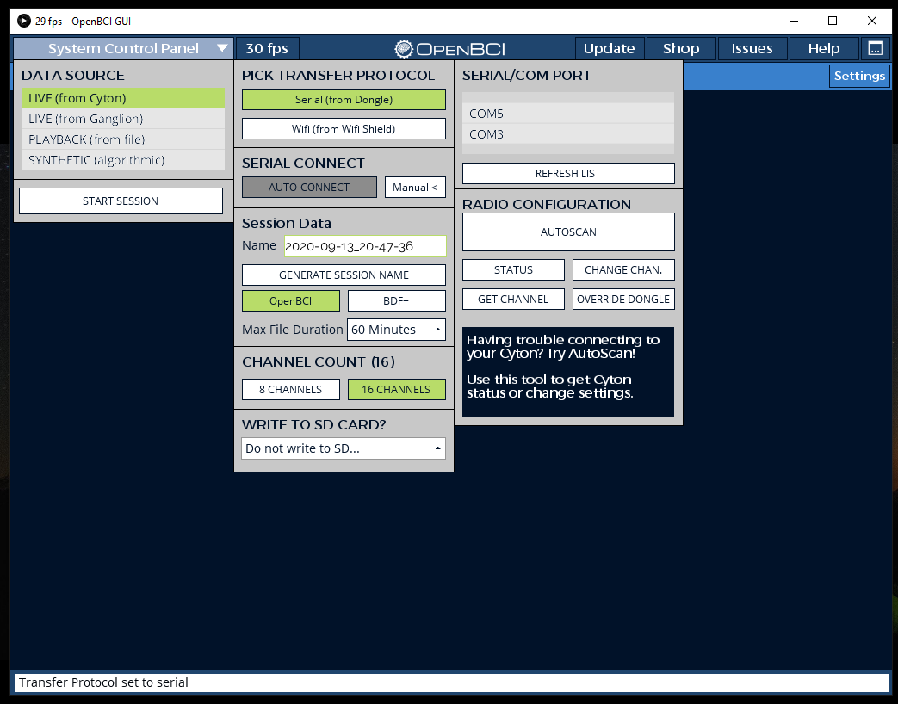
      2. **Serial/COM port:** Choose correct one  
         If unknown (depending on OS):  
         Open System Device Manager to see which serial port the dongle is connected to. In Windows OS, serial ports are named COM.
      3. Select **Autoscan** and follow any instructions shown at the bottom of the screen
5. Once connection is established (status bar at bottom of screen turns green), press **Start session** (top left corner)
6. A new screen will open
7. NEW Press Hardware settings (below Start Data Stream)  
   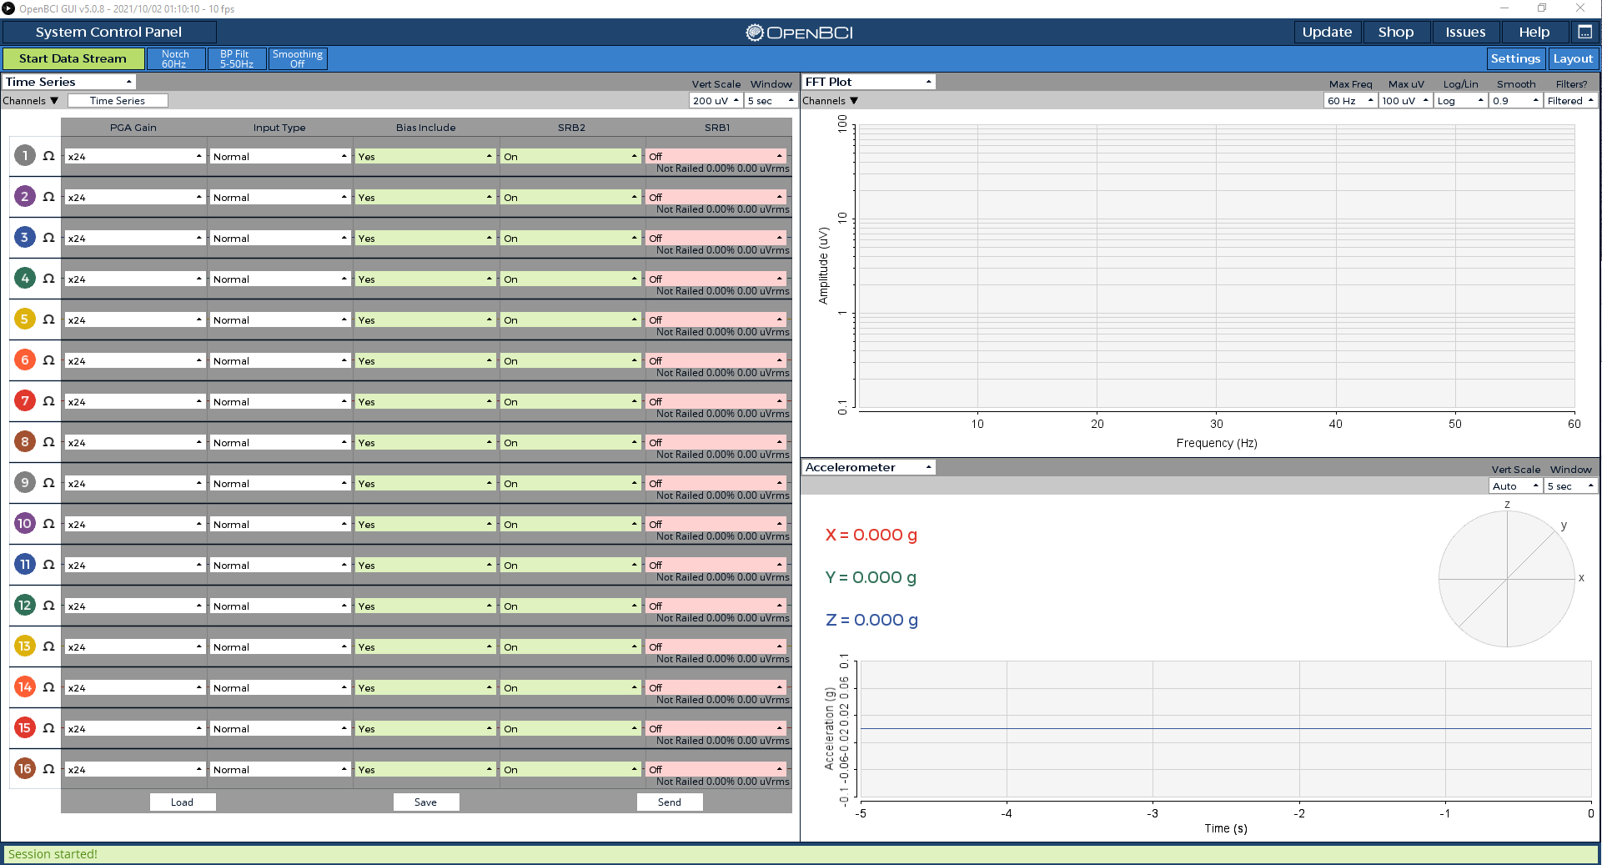
   1. Select Load  
      Load the file **Active6** form the [Firmware settings folder](https://drive.google.com/drive/folders/1sH0EMhJymKgCNcZEhoiCXpfOVR-BiEny?usp=sharing)
   2. Select **Send**
   3. Click Time series (where the hardware settings button was)
8. Press **Start data stream** (top left corner)  
   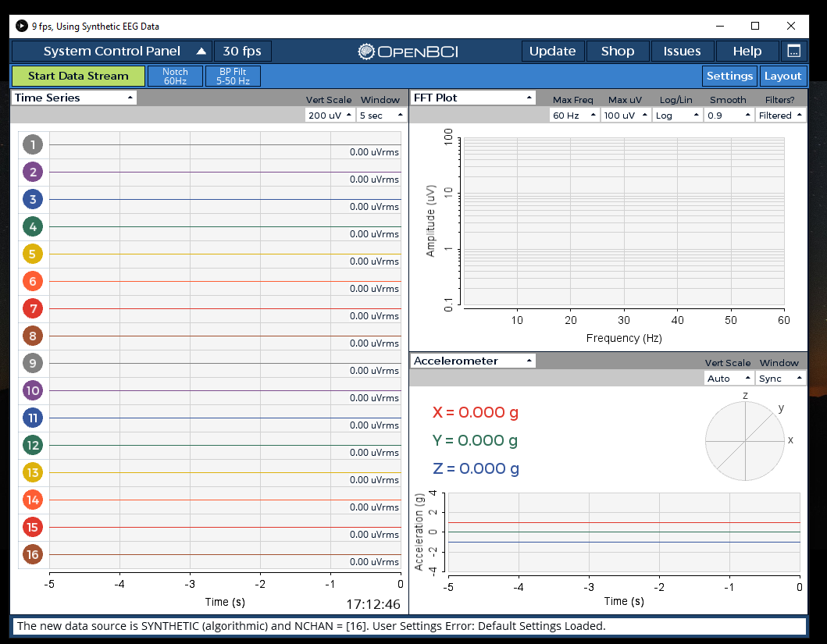
9. Troubleshooting
   1. No signal / Bad signal
      1. Make sure you've selected the correct serial/COM port
      2. Close OpenBCI GUI, power down your Cyton board and unplug your USB Dongle. Then, plug back in your USB Dongle,power up your Cyton board and open GUI in that order.
   2. Noise at 25Hz in FFT  
      Disconnect computer chargers / transformers in your surroundings.  
      Depending on the source of the disturbance, this may help.
   3. NEW Many railed electrodes, or no signal is visible
      1. Click **stop data stream**
      2. Adjust the hardware settings(as instructed above), by loading a lower (if railed) or higher (if no signal) ratio of amplification from the [Firmware settings folder](https://drive.google.com/drive/folders/1sH0EMhJymKgCNcZEhoiCXpfOVR-BiEny?usp=sharing)

## Set LSL broadcast

1. Open the dropdown menu at the top left corner of one of the widgets, and choose the **Networking** widget  
   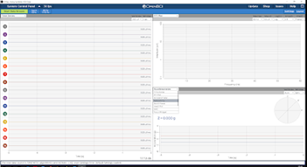
2. In Network widget, set:  
   **Protocol** (top right corner) to LSL  
   **Data Type** of **stream 1** to TimeSeries  
   **Data Type** of **stream 2 and 3** to None  
   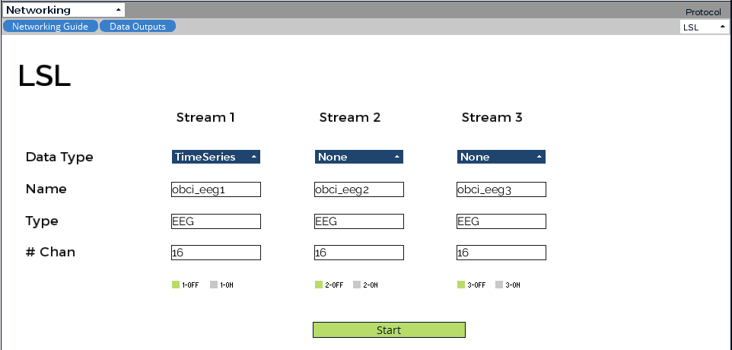
3. Press **Start**Note that the data being broadcasted is the raw data, without any GUI filters.

## End session

1. Stop LSL stream within Networking widget
2. Press **Stop Data Stream** (top right corner)
3. Exit OpenBCI GUI
4. Set board switch to off (middle position)
5. Disconnect the dongle and place it in the silver ziplock bag (for anti-static protection).
6. Remove batteries for storage and transport.

## OpenBCI GUI auto-recording (*.txt file)

OpenBCI GUI automatically saves every session as a *.txt file in the My Documents folder on your local hard drive.   
Back up these files together with your recordings, in your team’s Drive folder

# Placing the system on a participant

NEW

|  |  |
| --- | --- |

……………………………………………………………………………………………………………………………………………………………………………………………………………………………………………………………………………………………………………………………………………………………………………………………………………………………………………………………………………………………………………………………………………………………………………………………………………………………………………………………………………………………………………………………………………………………………………………………………………………………………………………………………………………………………………………………………………………………………………………………………………………………………………………………………………………………………………………………………………………………………………………………………………….

Getting to know the headset  
When first working with the headset, make sure you know where these are:

1. **Adjustable straps**Main strap (2 clips)
   * 1. Chin strap (1 adjuster)
     2. Dorsal cheek straps (2 adjusters)
     3. Frontal cheek straps (2 adjusters)
     4. Dorsal straps (2 adjusters)
     5. Frontal straps (2 adjusters)
2. **Board and wire casing**
   * 1. Board switch

Placing the headset

1. **Start fresh**
   1. Open all Adjustable straps to their maximum length  
      If the participant has already worn the headset, you may skip opening the main strip. Do open all the rest.
   2. Screw all electrode sockets out to their maximum (away from the head).
2. **Fit the main strap**
   1. Measure the head circumference of the participant with tape measure or string. Measure from the neck, just below the [inion](https://en.wikipedia.org/wiki/Inion) to the middle of the forehead.
   2. Adjust the main strap to the length you measured.   
      Make sure the Occipital electrodes are centered to the middle of the back strap
   3. Open one of the clips
   4. Place on participants.   
      Make sure frontal and dorsal straps are centered correctly
   5. Close clip
3. **Fit the Adjustable straps**
   1. Close the chin strap
   2. If the participant has long hair, clear it away from the electrodes using a **dull** pin or pencil.
   3. Make sure all electrodes are oriented correctly (flat, towards the head)  
      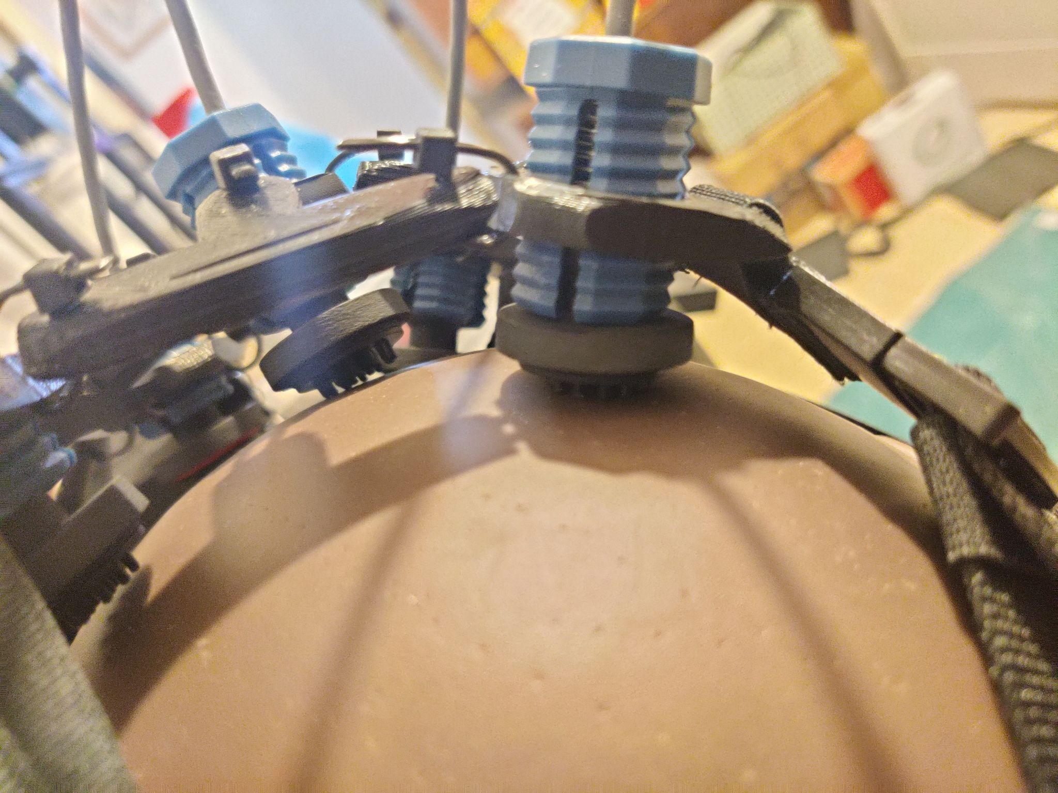
   4. Fasten (by order)
      1. Chin strap (1 adjuster)
      2. Dorsal cheek straps (2 adjusters)
      3. Frontal cheek straps (2 adjusters)  
         Make sure they are located far enough from the eyes, so they are comfortable. This is the reason they are fastened last.
      4. Dorsal straps (2 adjusters)  
         These straps should be tighter then all others, they pull the headset against the [inion](https://en.wikipedia.org/wiki/Inion) and fix it to its correct 10-20 position.
      5. Frontal straps (2 adjusters)  
         Lift the board case for easy access
4. **Fit the electrodes**
   1. Connect the earclips  
      Make sure to do it at this stage, so they are placed on top of the cheek straps
   2. Make sure all electrodes are oriented correctly (flat, towards the head)
   3. Make sure chin strap is tight (yet comfortable)
   4. If any electrode is loose, screw them in gently using the blue nuts.

# 

# Electrodes positions

## 10-20 positions

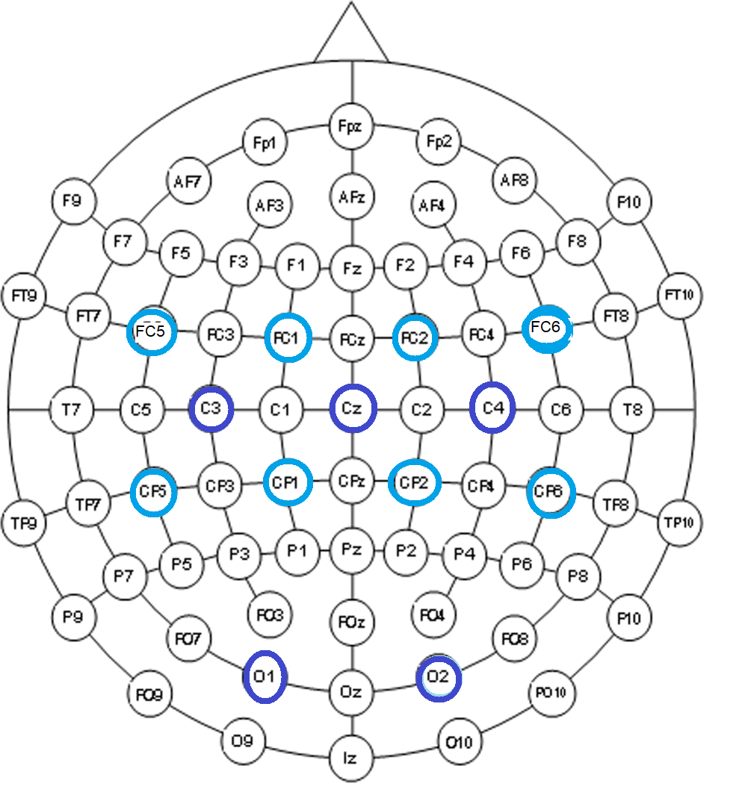

## Electrodes positions on openBCI board & GUI

| **GUI ID** | **10-20 Location** | **Pin ID** |
| --- | --- | --- |
| -- | Ear Clip  Reference | Cyton Bottom SRB pin (SRB2) |
| 1 | C3 | Cyton Bottom N1P pin |
| 2 | C4 | Cyton Bottom N2P pin |
| 3 | CZ | Cyton Bottom N4P pin |
| 4 | FC1 | Cyton Bottom N3P pin |
| 5 | FC2 | Cyton Bottom N6P pin |
| 6 | FC5 | Cyton Bottom N5P pin |
| 7 | FC6 | Cyton Bottom N8P pin |
| 8 | CP1 | Cyton Bottom N7P pin |
| -- | Ear Clip -  Digital Ground and noise cancelling | Cyton Bottom BIAS pin |
| -- | Ear Clip -  Reference | Daisy Bottom SRB pin (SRB2) |
| 9 | CP2 | Daisy Bottom N1P pin |
| 10 | CP5 | Daisy Bottom N2P pin |
| 11 | CP6 | Daisy Bottom N3P pin |
| 12 | O1 | Daisy Bottom N4P pin |
| 13 | O2 | Daisy Bottom N5P pin |
| 14 | N/A | Daisy Bottom N6P pin |
| 15 | N/A | Daisy Bottom N7P pin |
| 16 | N/A | Daisy Bottom N8P pin |

# Hardware overview & specs

## OpenBCI processing board and network dongle

Components

1. Cyton (8 channels) - large board
2. Daisy extension (additional 8 channels) - small board
3. USB Bluetooth dongle

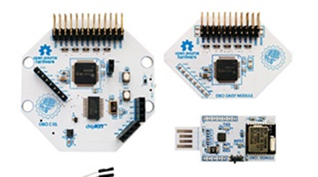

Boards are mounted at the back of the frame.  
Daisy board is mounted on top of Cyton board, using the boards’ communication pins.

Info and specs  
Network capability via dongle: 125 Hz for 16 electrodes. 250 Hz without Daisy extension.  
Pin layout - see electrodes’ positions section.

Arduino based system (inc. dongle).  
Firmware and hardware design can be found on MIT’s OpenBCI [GitHub](https://github.com/OpenBCI).  
Please DO NOT hack national headsets without consulting [Or Rabani](mailto:orabani@campus.haifa.ac.il) beforehand.  
  
Documentation:  
[Cyton Board](https://docs.openbci.com/docs/02Cyton/CytonLanding), [Cyton Getting Started Guide](https://docs.openbci.com/docs/01GettingStarted/01-Boards/CytonGS)

## 

## Headset

Info and specs  
The headsets are designed and pre-assembled by course staff.  
For any changes, consult Or Rabani through your TA.

**Do not fix hardware or change electrodes by yourself.**

# Additional resources

[Brainstorm IL slack](https://join.slack.com/t/israelbraincommunity/shared_invite/zt-h7a1gloy-suZveyFkgJgN0hKQIeRihA)  
[Neurotech X slack](https://neurotechx.com/slack/)

[OpenBCI Documentation](https://docs.openbci.com/docs/Welcome.html)

[OpenBCI · GitHub](https://github.com/OpenBCI)

[OpenBCI Forum](https://openbci.com/forum/)

# 